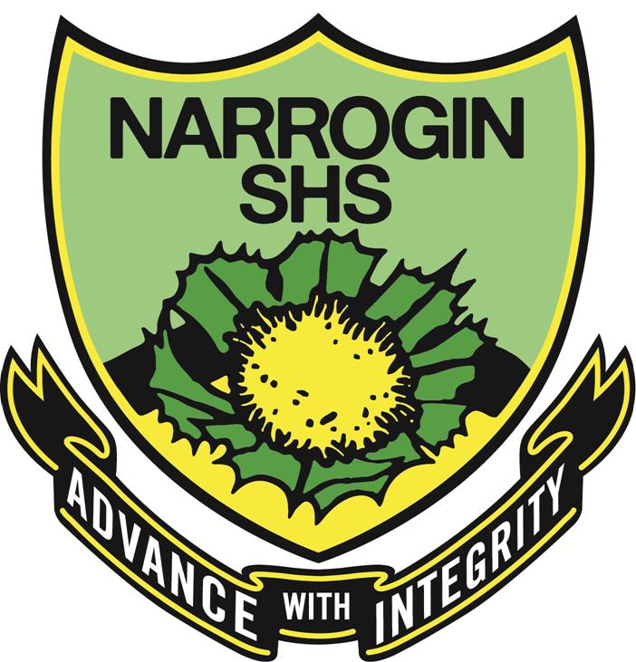

YEAR 9 FOUNDATION ENGLISH 2018

ASSESSMENT OUTLINE

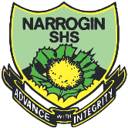 | Narrogin Senior High School  Assessment Outline Report: 2018 Semester One  Assessment Outline: 9 FOCUS  Duration: Year  Learning Area: English  Context: Global

Task | Outcomes | Sem | Max Score | % Weight
9 FOCUS

.. READING AND VIEWING

.... 2  Task 2: Short Story comprehension | Reading and Viewing | 1 | 100 | 5.0
.... 5  TASK 5: Study journal notes on the novel | Reading and Viewing | 1 | 100 | 5.0
.... 6  Task 6: Film Analysis study pack | Reading and Viewing | 1 | 100 | 5.0
.... 9  Task 9: Documentary analysis | Reading and Viewing | 1 | 100 | 5.0
.... 5  Task 10: Campaign advertisement | Reading and Viewing | 1 | 100 | 5.0
.... 12  EXAM | Reading and Viewing | 1 | 100 | 10.0
.. WRITING

.... 1  Task 1: Persuasive Essay | Writing | 1 | 100 | 5.0
.... 3  Task 3: Short story writing | Writing | 1 | 100 | 5.0
.... 5  TASK 5: Study journal notes on the novel | Writing | 1 | 100 | 5.0
.... 7  Task 7: Production of own Manga page | Writing | 1 | 100 | 5.0
.... 9  Task 9: Documentary analysis | Writing | 1 | 100 | 5.0
.... 12  EXAM | Writing | 1 | 100 | 10.0
.. SPEAKING AND LISTENING

.... 4  Task 4: Oral Presentation of narrative | Speaking and Listening | 1 | 100 | 10.0
.... 8  Task 8: Present own manga page to the class | Speaking and Listening | 1 | 100 | 10.0
.... 11  Task 11: Oral Presentation of advertisement | Speaking and Listening | 1 | 100 | 10.0
Semester 1 % Total Weight |  |  |  | 100.0
Semester 2 % Total Weight |  |  |  | 0.0
Total Weight |  |  |  | 100.0

